**Lingaya's Vidyapeeth**



2022-2023

Nachauli, Jasana Road, Old Faridabad, Haryana - 121003

2022-2023

Name: Abhishek Kumar

Roll No: 21BCA31

Course Name: Multimedia Technologies Lab

Course Code: CA-1256A

Programme: BCA 3RD Semester

Submitted to: Ms. Ishita Bajaj

**Multimedia Technologies**

**LAB MANUAL**

**Experiment – 01**

**Aim:** Create a Motion Tweening using Macromedia Flash (Moving Ball).

**Procedure:**

1. Open Macromedia flash
2. Select Oval Tool and draw a ball
3. Go to Timeline and insert a keyframe at any frame let’s say 20.
4. Move the ball to final location in canvas.
5. Now right click between those two frames and select Create Motion Tween.
6. Now Press Ctrl+Enter to export and play

**Output:**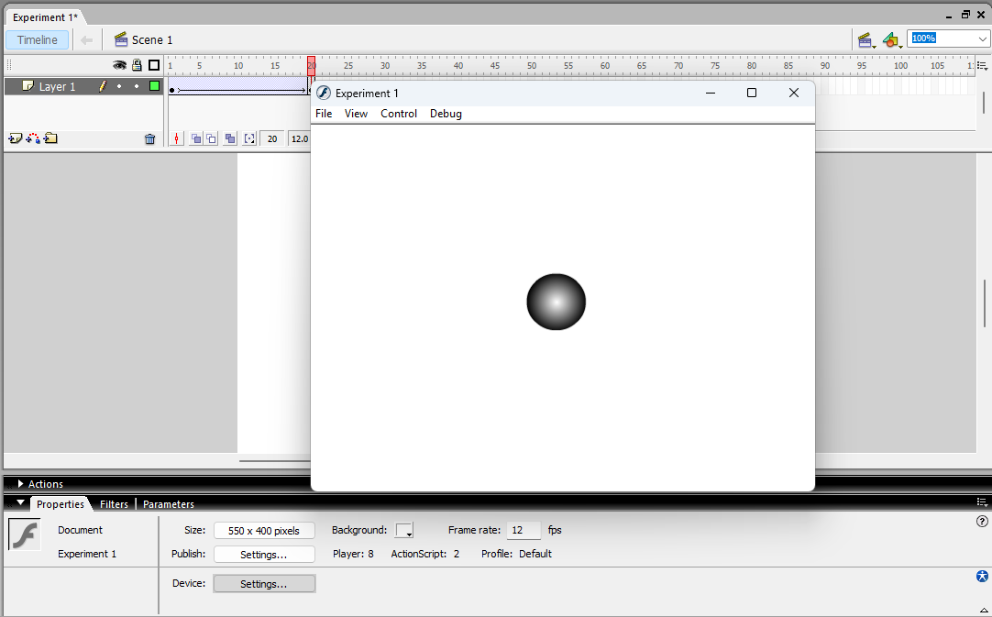

**Experiment – 02**

**Aim:** Design a moving ball in V shape.

**Procedure:**

1. Open Macromedia flash
2. Select Oval Tool and draw a ball
3. Go to Timeline and insert a keyframe at any frame let’s say 15
4. Now move the ball in canvas to bottom
5. Go to Timeline and insert a keyframe at any frame let’s say 30
6. Now move the ball to upper part of the canvas creating a V like shape
7. Now right click between those two keyframes and select Create Motion Tween.
8. Now Press Ctrl+Enter to export and play

**Output:**

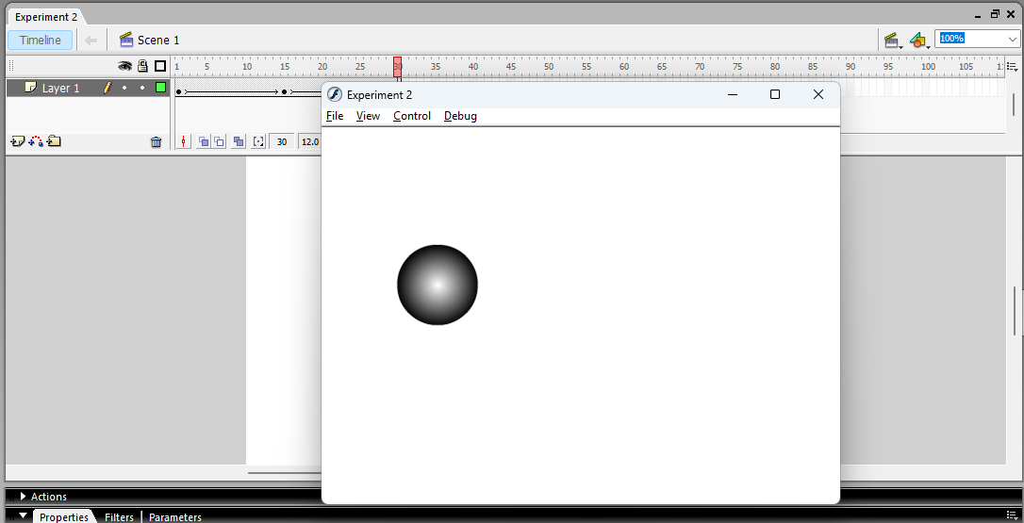

**Experiment – 03**

**Aim:** Design a moving ball in V shape.

**Procedure:**

1. Open Macromedia flash
2. Select Oval Tool and draw a ball
3. Go to Timeline and insert a keyframe at any frame let’s say 10
4. Now move the ball in canvas to bottom
5. Go to Timeline and insert a keyframe at any frame let’s say 20
6. Now move the ball in canvas to upper part
7. Go to Timeline and insert a keyframe at any frame let’s say 30
8. Now move the ball in canvas to bottom
9. Go to Timeline and insert a keyframe at any frame let’s say 40

10.Now move the ball in canvas to upper creating a W like shape

1. Now right click between those two keyframes and select Create Motion Tween.
2. Now Press Ctrl+Enter to export and play

**Output:**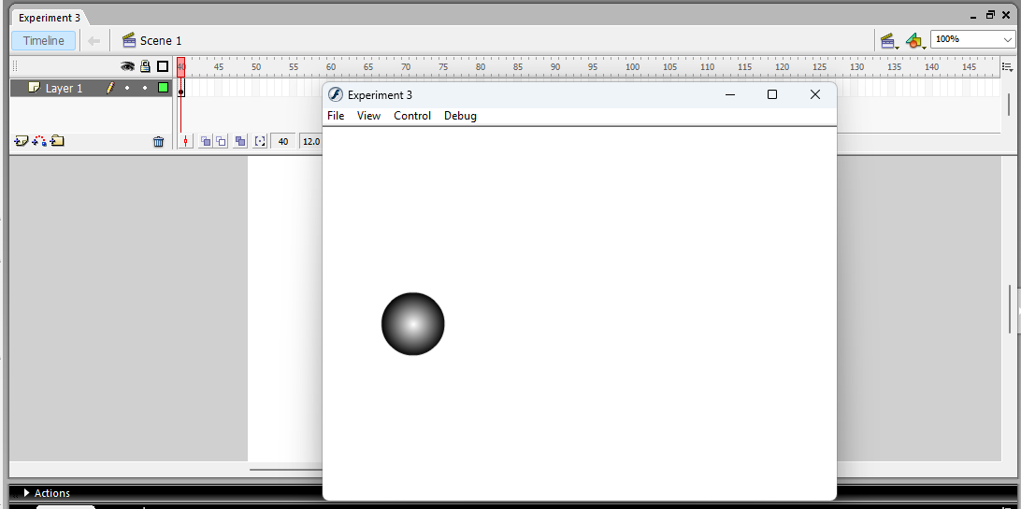

**Experiment – 04**

**Aim:** Design a shape tweening – Object to object.

**Procedure:**

1. Open Macromedia flash
2. Now select the Rectangle Tool to draw a rectangle
3. Go to Timeline and insert a keyframe at any frame let’s say 15
4. Now using oval tool draw a circle and erase the previous rectangle
5. Now right click between those keyframes and select Create Shape Tween
6. Now Press Ctrl+Enter to export and play

**Output:**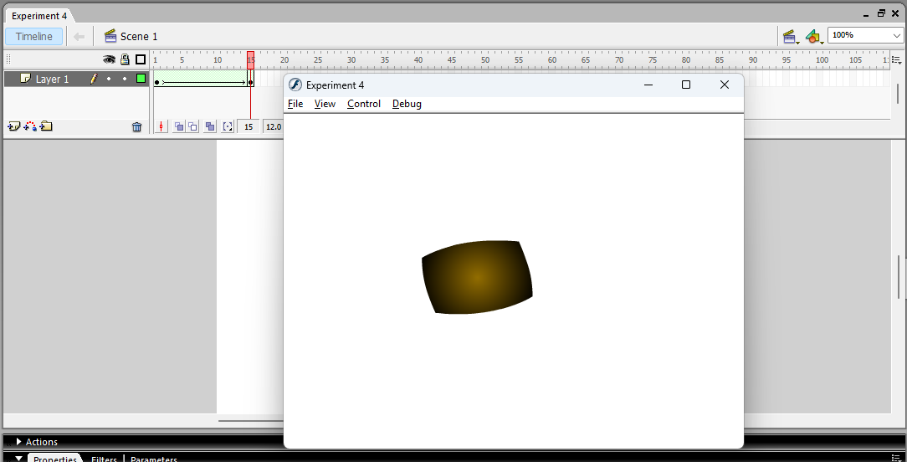

**Experiment – 05**

**Aim:** Design a shape tweening – Object to Alphabet.

**Procedure:**

1. Open macromedia flash
2. Now using Oval tool, draw a Circle
3. Go to Timeline and insert a keyframe at any frame let’s say 20
4. Now using pencil tool draw the letter A and erase the previous circle
5. Now right click between those keyframes and select Create Shape Tween
6. Now Press Ctrl+Enter to export and play

**Output:** 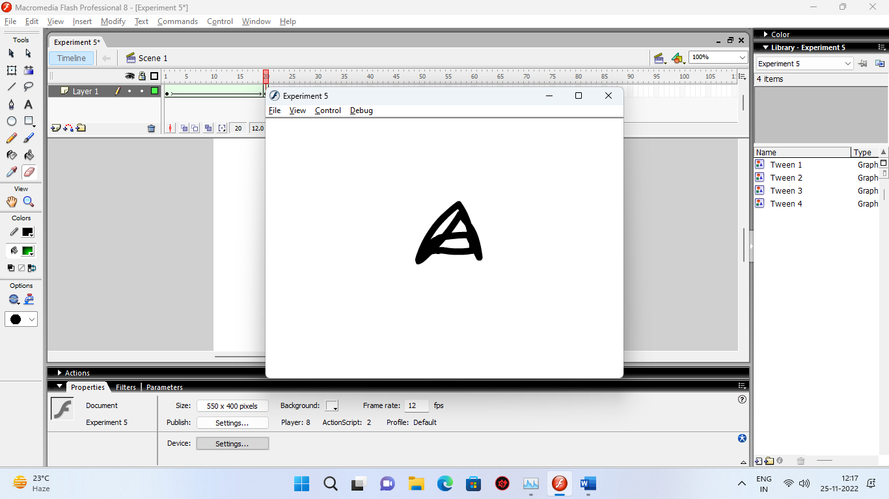

**Experiment – 06**

**Aim:** Design a shape tweening – Alphabet to Object.

**Procedure:**

1. Open macromedia flash
2. Now using pencil tool, draw the letter A
3. Go to Timeline and insert a keyframe at any frame let’s say 20
4. Now using rectangle tool draw the rectangle and erase the previously drawn letter
5. Now right click between those keyframes and select Create Shape Tween
6. Now Press Ctrl+Enter to export and play

**Output:**

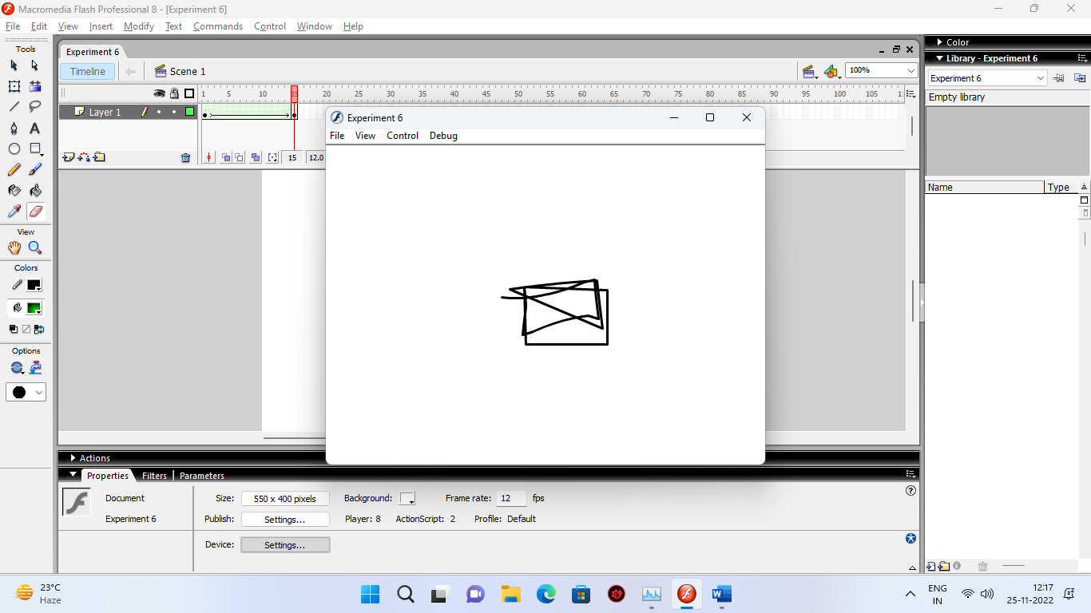

**Experiment – 07**

**Aim:** Create Spotlight using Macromedia Flash.

**Procedure:**

1. Open Macromedia flash
2. Now using Rectangle tool draw a rectangle covering whole canvas
3. Insert new layer
4. Using text tool, write any word let’s say “ABHISHEK KUMAR”
5. Insert another layer
6. Using oval tool, create a circle with size just over font size.
7. Right click on 3rd layer and select mask
8. Now Press Ctrl+Enter to export and play

**Output:**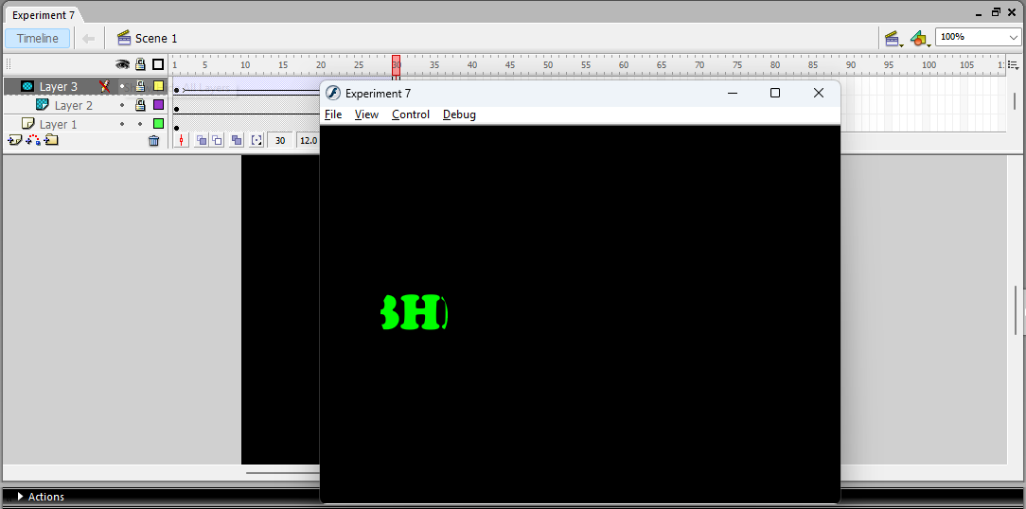

**Experiment – 08**

**Aim:** Implement Splitting of ball.

**Procedure:**

1. Open Macromedia Flash
2. Using oval tool, draw a circle
3. Right click on the object select timeline effect > Effect > Explode.
4. Now Press Ctrl+Enter to export and play

**Output:**

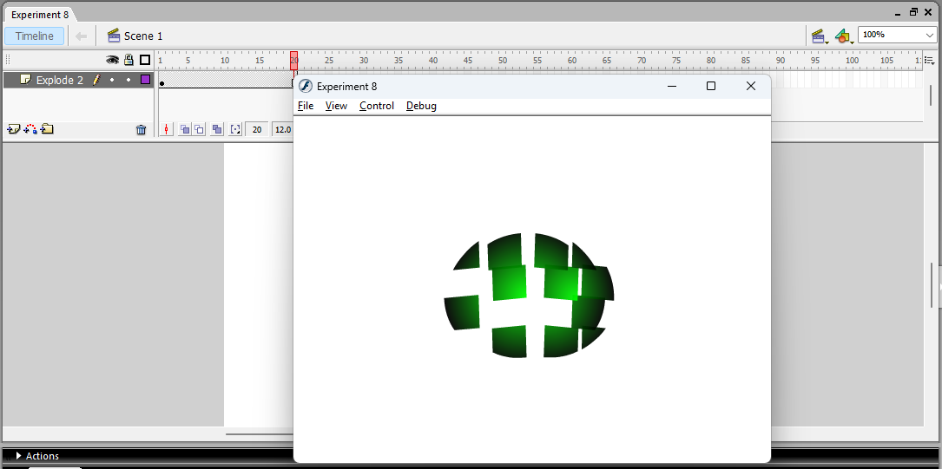

**Experiment – 09**

**Aim:** Create Animated Pool Table.

**Procedure:**

1. Open Macromedia Flash
2. Using Rectangle tool draw a rectangle with larger border width.
3. Insert 2nd layer
4. Using line tool draw pool stick
5. Insert another layer and draw a ball on that
6. Repeat step 4 and 5 till you get desired number of balls
7. Using Motion tween, animated each ball and stick separately
8. Now Press Ctrl+Enter to export and play

**Output:**

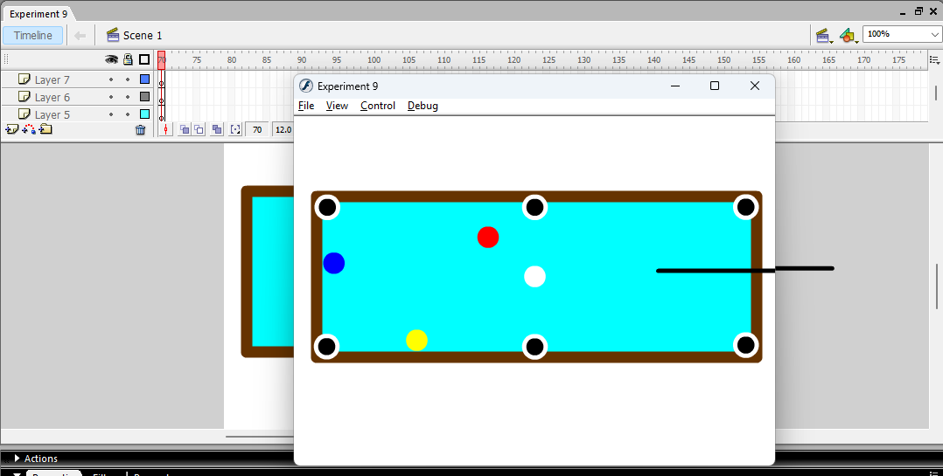

**Experiment – 10**

**Aim:** Create Bow & Arrow hitting a Ball.

**Procedure:**

1. Open macromedia flash
2. Now go to file > import > import to stage > select file > open
3. Insert 2nd layer
4. Using oval tool, draw multiple circles overlapping each other so that it looks like target
5. Insert another layer and using pen tool draw a bow
6. Insert another layer and using line tool draw an arrow
7. Animated bow string and he arrow separately by using motion tween
8. Now Press Ctrl+Enter to export and play

**Output:**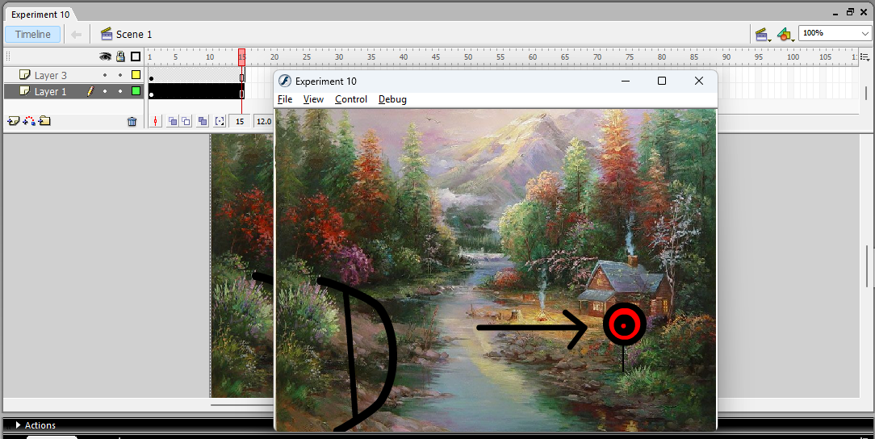

**Experiment – 11**

**Aim:** Write any text with the illusion of pen writing letters.

**Procedure:**

1. Open macromedia flash
2. Using pencil tool write any text let’s say “KMAAR”
3. While pressing F6 key erase the text frame by frame
4. Select all the frames on the timeline and right click on it and select Reverse Frames
5. Now Press Ctrl+Enter to export and play

**Output:**